Invitation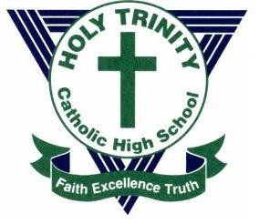 | GRADE SEVEN PARENT INFORMATION NIGHT

Thursday, January 23rd, 2020
Holy Trinity Catholic High School invites all parents of Grade 6 Students to an Information Night and Open House on Thursday, January 23rd at 7:00pm

Topics Covered:  School Policies & Procedures  Understanding a 5-Day Cycle Timetable  Special Education  Student Services  Report Cards & Interviews  French Programs  Extracurricular Activities & Student Life  Helping Your Child to Make the Transition | The evening will provide parents with information about what to expect for their Grade 7 Student(s) at Holy Trinity. Parents are invited to:  • attend a presentation led by Student Services in the Cafetorium  • learn about extracurricular activities offered at Holy Trinity  • discover what life is like for an intermediate student at HT  • hear from Counsellors, Resource Teachers, and Curriculum  Leaders  We look forward to welcoming you to our school community and introducing you to all that Holy Trinity has to offer!  Please Note:  Students coming from Holy Redeemer, St. Anne, St. James and St. Martin de Porres are automatically registered at Holy Trinity. It is not necessary to complete a registration package.
Holy Trinity Catholic High School
180 Katimavik Road, Kanata, ON K2L 4A7 (613) 591-9955
email: HolyTrinity.High@ocsb.ca Website: http://trh.ocsb.ca
@HolyTrinity_CHS

